**Documentation for SFTP/FTP Setup with AWS Transfer, WinSCP, and FileZilla**

**1. Understanding SFTP and FTP**

**What is FTP?**

File Transfer Protocol (FTP) is a standard network protocol used to transfer files between a client and a server over the internet. FTP is not secure by itself and transfers data in plain text.

**What is SFTP?**

Secure File Transfer Protocol (SFTP) is a secure version of FTP that uses SSH (Secure Shell) to encrypt data during transmission, ensuring the confidentiality and integrity of the files.

**What is AWS Transfer Family?**

AWS Transfer Family is a managed service that supports file transfers over SFTP, FTPS, and FTP directly into and out of Amazon S3 or Amazon EFS. It simplifies the setup of secure file transfers, eliminating the need to manage infrastructure.

**2. Setting Up AWS Transfer Family**

**Steps:**

1. **Create an AWS Transfer Family Server:**
   * Navigate to the AWS Transfer Family console.
   * Choose "Create server" and select the protocol (e.g., SFTP).
   * Specify the associated S3 bucket or EFS for file storage.

**Screenshot:**

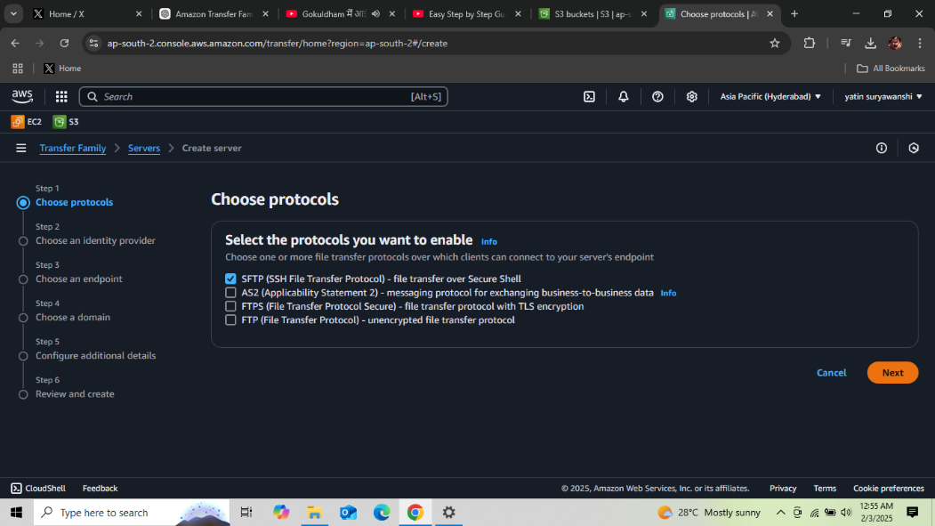

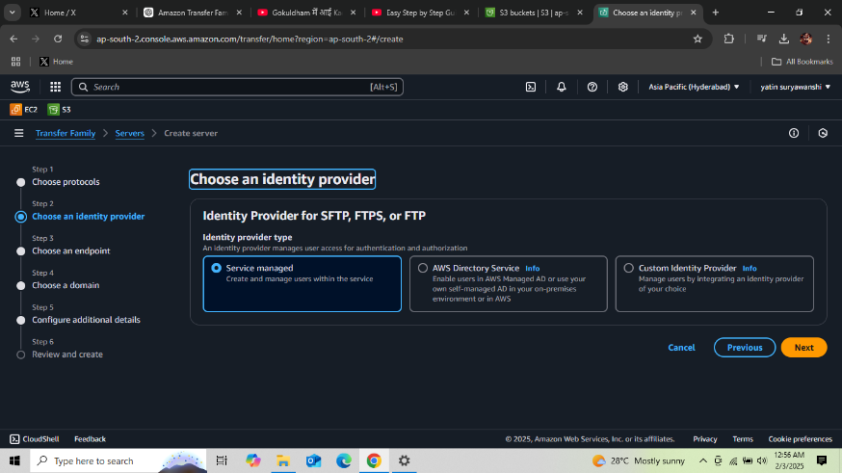

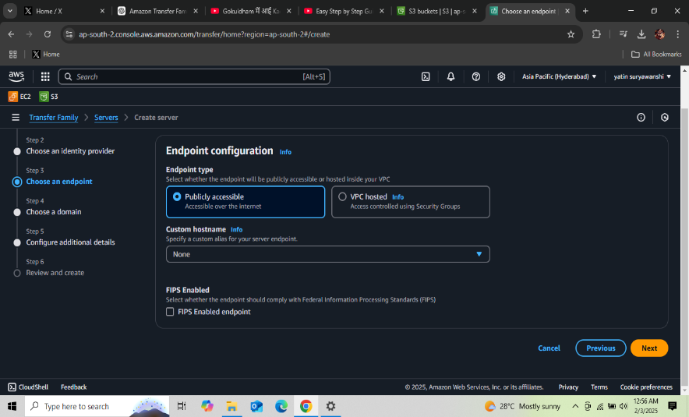

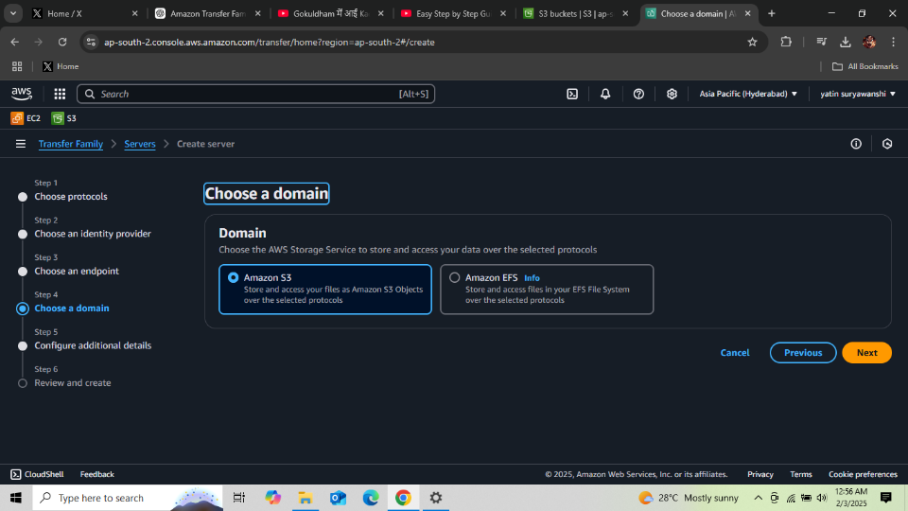

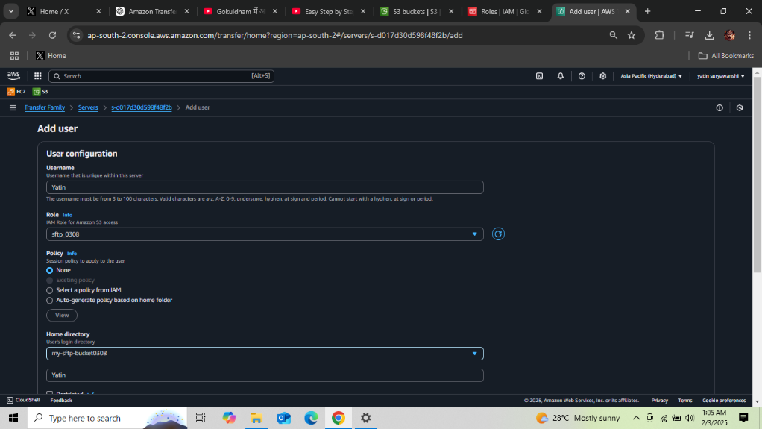

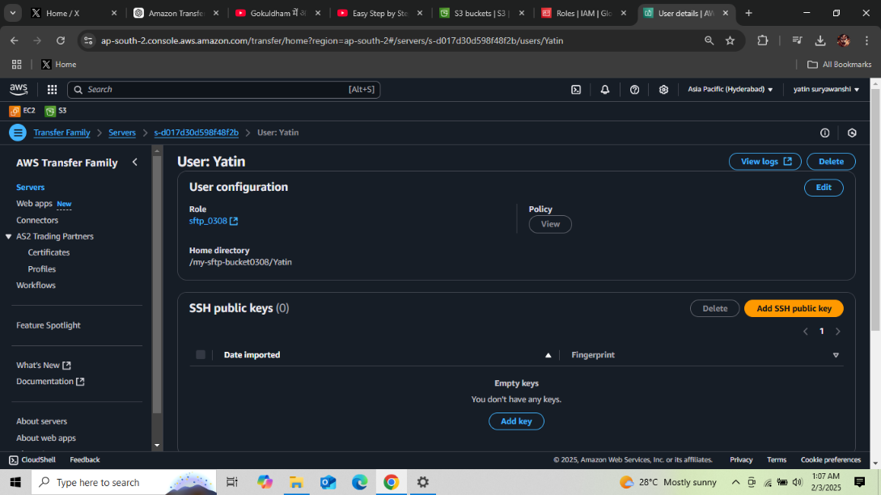

**Set Up IAM Role:**

* + Create an IAM role with policies granting access to the S3 bucket.
  + Attach the role to your AWS Transfer Family server.

**Screenshot:** Show the IAM policy setup and role assignment.

1. **Configure Users:**
   * Add users to the AWS Transfer Family server with a username, home directory, and public SSH key.

**3. Using WinSCP to Connect to AWS Transfer**

**Steps:**

1. **Download and Install WinSCP:**
   * Download WinSCP from <https://winscp.net>.
2. **Add Key File:**
   * Open WinSCP and go to "Session > New Session."
   * Enter the SFTP server details (e.g., hostname, username, and port 22).
   * Under "Advanced > Authentication," select the private key file (.ppk).
3. **Connect to AWS Transfer Server:**
   * Click "Login" to establish the connection.
   * Drag and drop files for transfer.

**Screenshot:**

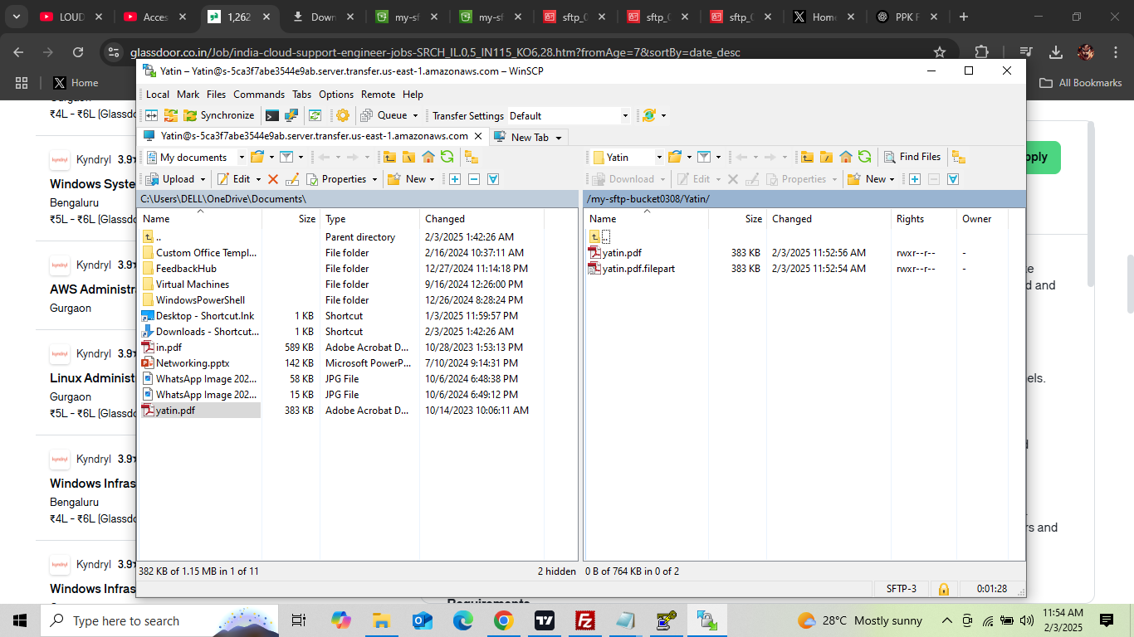

**4. Using FileZilla to Connect to AWS Transfer**

**Steps:**

1. **Download and Install FileZilla:**
   * Download FileZilla from <https://filezilla-project.org>.
2. **Configure Connection:**
   * Go to "File > Site Manager."
   * Enter the SFTP server details (e.g., hostname, username, port 22).
   * Add the private key file under "Key file" in the SFTP settings.

**Screenshot:**

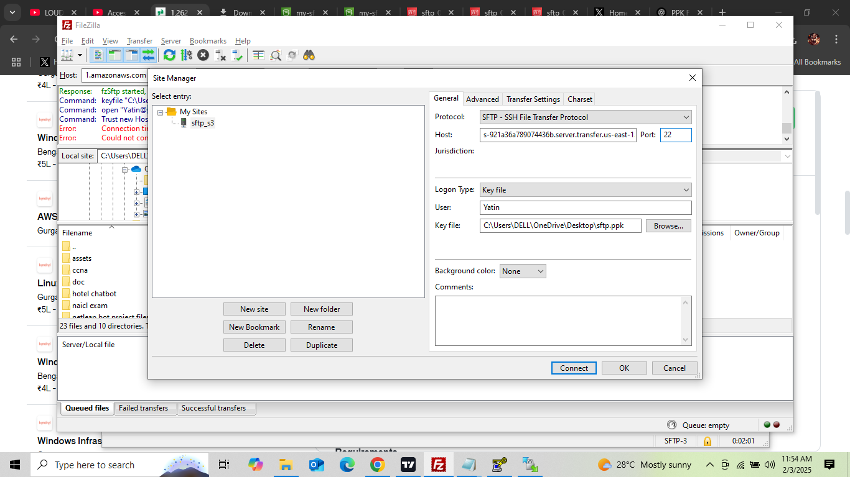

1. **Connect to AWS Transfer Server:**
   * Click "Connect" and navigate the directory.
   * Transfer files by dragging and dropping.

**Screenshot:**

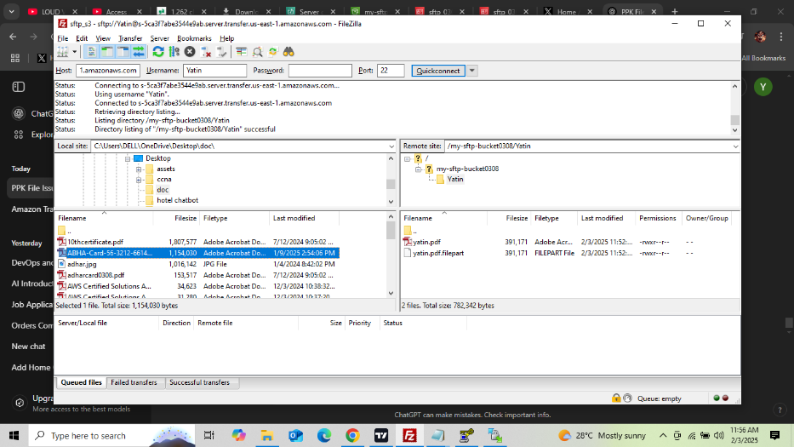

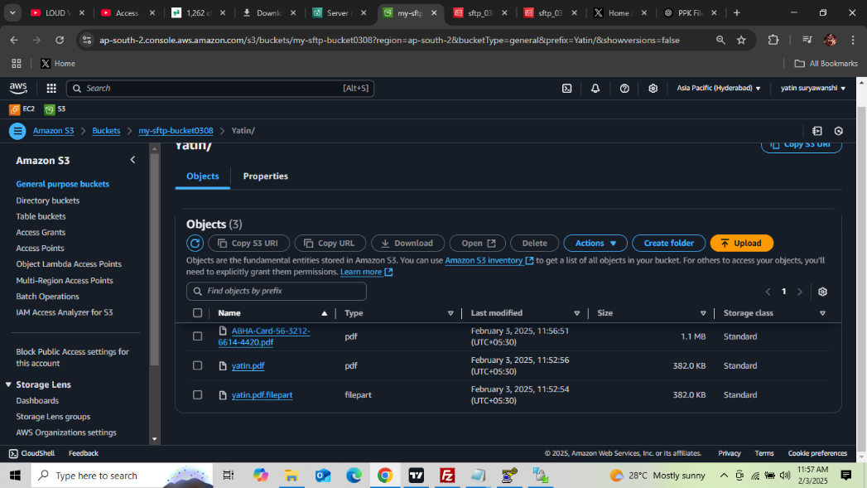

**5. Troubleshooting Common Issues**

**1. Permission Denied**

* Ensure the IAM role has the correct permissions to access the S3 bucket.
* Verify the public SSH key is correctly uploaded for the user.

**Screenshot:** Include an example of the "Permission Denied" error.

**2. Timeout Issues**

* Verify that the server's endpoint is reachable.
* Ensure the security group allows inbound traffic on port 22.

**Screenshot:** Show a security group configuration.

**6. Summary**

This documentation covered the basics of SFTP/FTP, AWS Transfer Family, and the setup processes using WinSCP and FileZilla. Screenshots can be added at each mentioned point for clarity and ease of understanding.

**Additional Notes:**

* Ensure your private key file (.ppk) is securely stored.
* Always test the connection after setup to confirm access.
* For detailed error logs, check AWS CloudWatch logs for the AWS Transfer Family server.